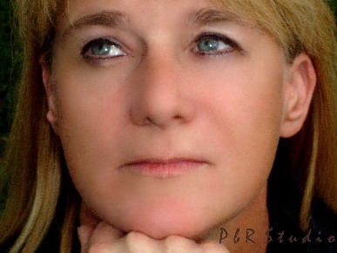
Author J. F. Bolles lives in Ohio with her husband, Dave.
She is a devoted Christian, mother and grandmother. She is thankful to those who encouraged her to write her story.

